***Week 2 – Wednesday AM Problem Set:***

***Switch Debouncing, Automatic Resets, and Counters***

**Problem 1:**

Your kit contains 68mF capacitors and 100W, 430W, 470W, and 10kW resistors.

Using the parts in your kit, design a switch debounce circuit by choosing a value for R2 so that the RC time constant is about 30 ms.

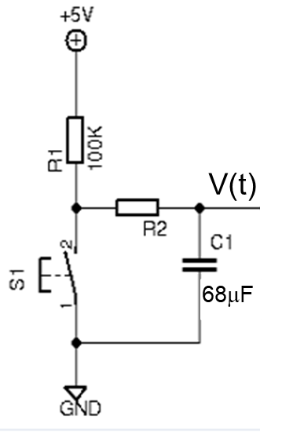

**R2 = 430ohms**

430ohms x 68 microfarads = .0292 sec -> 30 ms

Sketch the voltage vs time graph for the output of the circuit, V(t):

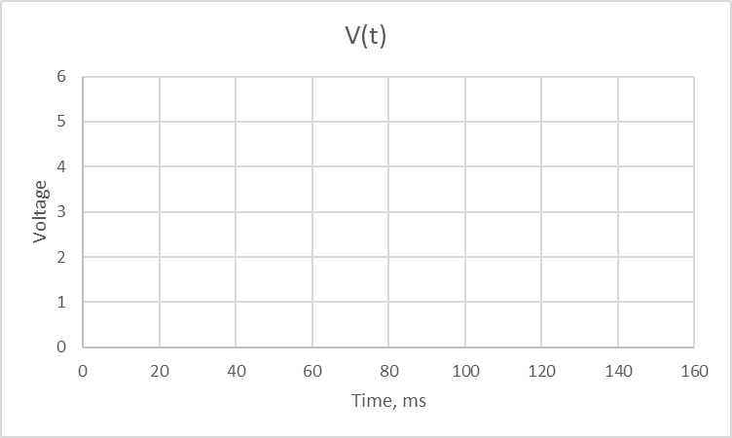



**Problem 2:** Implement a power-on reset for the custom synchronous counter from Tuesday afternoon’s ICE (repeated below).

Given this state table, construct a **synchronous custom counter** using **D-type flip flops**. Implement an RC circuit that initializes the system to 000 on power-up. Note: Logisim does not have capacitors, so you cannot simulate the power-on reset in Logisim. Just draw the circuit diagram below.

Hint: Construct Karnaugh maps by filling in where Dc, Db, and Da are 0, 1 or x respectively.

|  |  |  |  |  |  |  |  |  |
| --- | --- | --- | --- | --- | --- | --- | --- | --- |
| tn | | | | | | tn+1 | | |
| Qc | Qb | Qa | Dc | Db | Da | Qc | Qb | Qa |
| 0 | 0 | 1 | 1 | 0 | 0 | 1 | 0 | 0 |
| 1 | 0 | 0 | 1 | 1 | 1 | 1 | 1 | 1 |
| 1 | 1 | 1 | 0 | 0 | 0 | 0 | 0 | 0 |
| 0 | 0 | 0 | 0 | 1 | 1 | 0 | 1 | 1 |
| 0 | 1 | 1 | 1 | 0 | 1 | 1 | 0 | 1 |
| 1 | 0 | 1 | 0 | 0 | 1 | 0 | 0 | 1 |
| 0 | 1 | 0 | x | x | x | x | x | x |
| 1 | 1 | 0 | x | x | x | x | x | x |

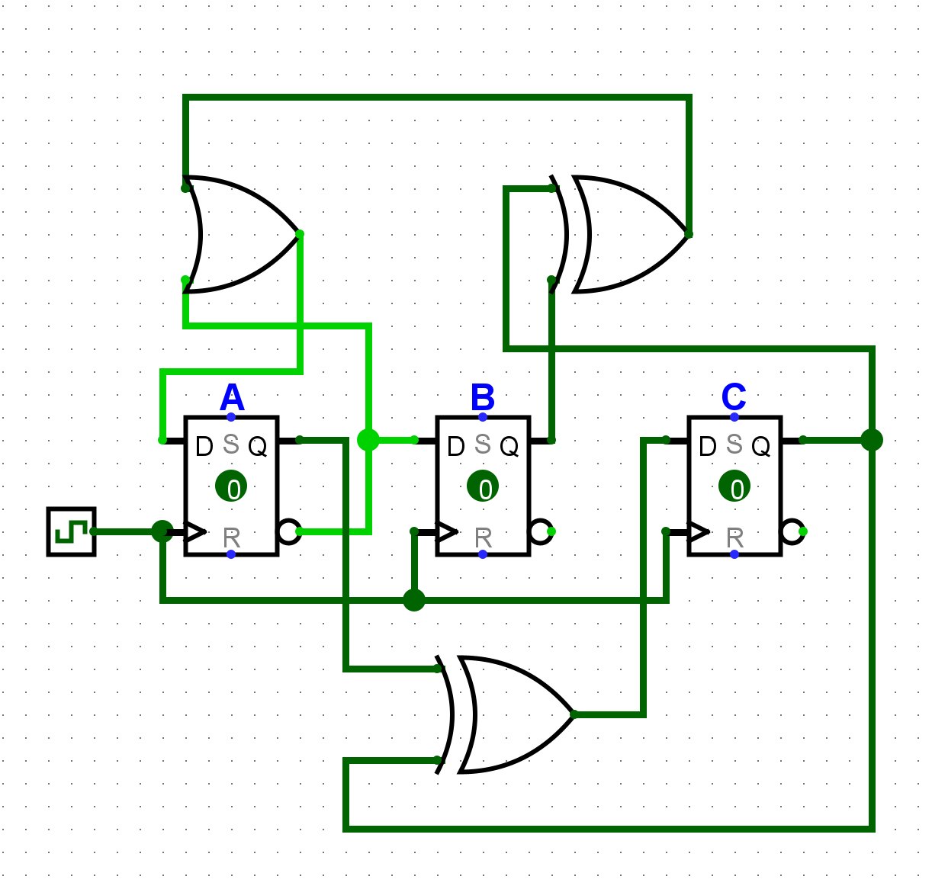



Challenge: Initialize the system to 001 on power up.

If active low, power them

If active high, ground them

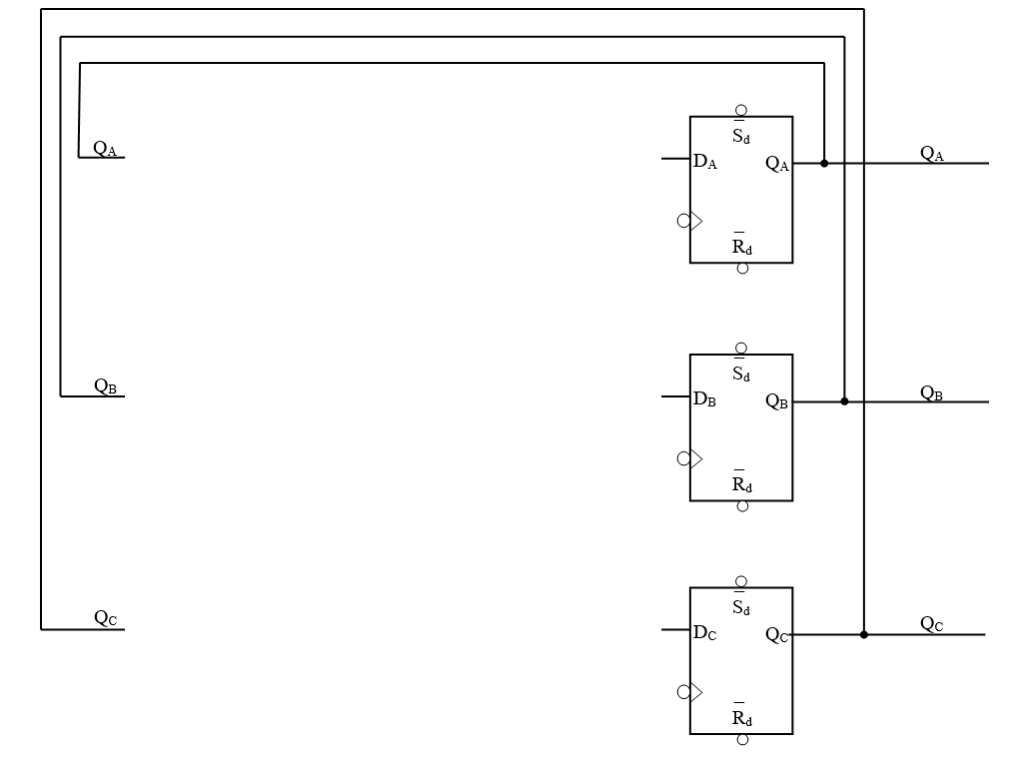

Active High RC



**Problem 3:** Configure a CD4029B to continuously count from 0000 to 1111 and then start again at 0000. 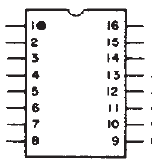

0 (Preset)

0 (Carry IN)

1 (Binary)

1 (Count UP)

0

0

**Clock**

0

0

**GND**

**+5V**